-


[State Department]
GAAP Expenditure/Expense Accrual Standard Operating Procedures (SOP)
How to Use this Template
-------------------Delete this Page Prior to Finalizing SOP-------------------
This template is intended to help develop detailed Standard Operating Procedures (SOPs) for your Department’s accrual process for Generally Accepted Accounting Principles (GAAP) financial reporting. Below are some helpful ways to utilize this template for your specific GAAP accruals SOP.

- The default picture on the title page is the Capitol Building, and the logo is the California State Seal
  - If desired, right-click the Capitol picture or California State Seal and select “Change Picture” to replace with your Department-specific details
- There are some commonly defined placeholders, where you can search and replace the placeholder with your department-specific information, and this will update the full document (recommend reviewing the document to validate once all updates have been made)
  - [Procedure Name] – this is the name of the procedure
  - [State Agency] – this is the Agency name
  - [State Department] – this is the Department name
  - [Administration Division] – each Department/Agency has their own unique name for the Administration Division, so this can be used to input your specific Department/Agency nomenclature
  - [Program] – this is the specific government program for the procedures
- Departments should engage with program staff to determine how the GAAP criteria applies to each program
  - Depending on how the programs are structured (if there are unique circumstances or scenarios), it may be necessary to create a procedure for each individual program or type of program (i.e., reimbursement programs, advanced funding programs, State vs. Federally-funded programs)
Note: This is intended as a template to help facilitate the development and documentation of detailed accrual procedures. This is not intended to be exhaustive, so most procedures will require more detail (and in some cases, significantly more) than reflected in this template. If you need assistance or have questions on how to create procedures, please reach out to the State Controller’s Office (SCO) for support.
-------------------Delete this Page Prior to Finalizing SOP-------------------

Version History
The following table tracks when and what changes were made to the department’s GAAP Accrual Policies and Procedures document.

VERSION # | DATE | AUTHOR | SUMMARY OF CHANGES
0.1 |  |  | Initial Draft

Table of Contents
Background 4
Roles and Responsibilities 5
Grant Accruals Process 6
Initiate Status of Funds Data Call 6
Collect Data Call Responses 12
Validate Responses against FI$Cal Data 13
Evaluate Calculation of Estimated Accruals 14
Consolidate Accrual Entries by Fund 14
Record Accruals 14
Program Procedures 15
[Division and/or Program Name] 15
Key Supporting Documents 17
Acronyms 18

Background
The purpose of this document is to define the [State Department] procedures when recording the year-end Generally Accepted Accounting Principles (GAAP) adjusting journal entries related to grant accruals. This includes data call procedures to collect data, including data that resides outside the financial reporting system (FI$Cal), from various programs.
This document provides a summary for each unique grant program or grant program type, detailing the components of the grant agreement(s) and the criteria or triggering points for meeting the grant eligibility requirements. It also outlines the procedural steps taken by each program to identify the complete population of eligible grantees, the source documentation used, and the methods for classifying certain expenditures or invoices as accruals. Finally, it includes a description of the process and applicable methodology for estimating accruals for each program in preparing the accounting entries for [State Department] to record the grant accruals.
California Government Code Section 12460 requires the State Controller’s Office (SCO) to issue an annual financial report that is prepared in accordance with Generally Accepted Accounting Principles (GAAP). To prepare this financial report, SCO annually requests that departments submit GAAP-related adjustments for the funds they administer, which are compiled to prepare the State’s Annual Comprehensive Financial Report (ACFR). As prescribed in Governmental Accounting Standards Board (GASB) Codification 1600, the financial statements for governmental funds should be presented using the current financial resources measurement focus and the modified accrual basis of accounting. The measurement focus of governmental fund financial statements is on near-term inflows and outflows of spendable resources. Consequently, under this measurement focus most expenditures are measurable and reportable when they are paid. However, the ACFR uses the accrual basis of accounting (economic resources measurement focus), which requires expenditures/expenses to be recognized when costs are incurred, whether they are paid or not. While some expenditures/expenses may not be practicably measurable until cash is disbursed, GAAP requires a reasonable methodology of estimating additional GAAP expenditure/expense accruals for invoices either not received by fiscal year-end or otherwise not accrued during the departmental preparation of governmental fund financial statements.
The State is often a pass-through grantor for subrecipients (i.e. counties and other local governments, non-profit organizations) who are the ultimate spenders of federal awards. The following are the two types of funding methods from the federal government for state departments that receive and issue grants:
Advance Funding | [State Department] receives funding (typically from the federal government) to award to sub-recipients in the form of loans and grants. When the eligibility requirements for these federal programs have not been satisfied upon the State’s receipt of the cash, the revenue cannot be recognized and must be recorded as an advance. Prior to the fiscal year-end accrual, [State Department] records revenue for the advanced funding from the federal government, and expenditures for the disbursement of these funds to sub-recipients, which is aligned with the Budgetary/Legal accounting method. For purposes of the ACFR, both the revenue and expenditures must be adjusted to conform to GAAP reporting standards.  NOTE: Eligible costs cannot be incurred by the State or its subrecipients until an approved grant contract has been executed, per GASB Codification N50.104.d. Costs incurred prior to execution of an approved grant contract typically must be recognized as liabilities to the federal government and receivables from subrecipients.
Reimbursable Funding | [State Department] incurs expenditures related to programs which align with the organization’s operational objectives. The expenditures may consist of any combination of direct expenditures of the State and disbursements to subrecipients. Program-eligible expenditures are submitted periodically for reimbursement from the federal grantor agency. At year-end, [State Department] adjusts the expenditure amounts on a GAAP basis to include only incurred costs reported by sub-recipients to capture incurred liabilities.
The following is a list of the related GAAP adjustments:
- Reverse encumbrances for funding received in advance.
- Reverse revenue for funding received in advance.
- Eliminate Sub-recipient’s unspent award.
- Record Sub-recipient expenditures more than the awarded amount

Roles and Responsibilities
The following stakeholders participate in the execution of this process.
[State Department] Procedure Process Owners
Role | Responsibility
Accounting Branch Chief, [Administration Division] | Process Owner, updates accruals workbook
Chief Financial Officer, [Administration Division] | Reviewer
Grant Program Division leads | Collects responses from Sub-Recipients and provides responses to the Accounting Branch Chief
Sub-Recipients | Provide grant funding input to Grant Program Division leads

Grant Accruals Process
The Grant Accruals Process contains five steps:
- Sending a data call to initiate the status of funds.
- Collecting data call responses.
- Validating responses against FI$Cal records and adjusting, as necessary, for accruals already posted during the preparation of governmental fund financial statements.
- Evaluating calculation of estimated accruals against approved program specific methodology.
- Recording the accruals.

Initiate Status of Funds Data Call
The first step, initiating the "Data Call," involves gathering the information needed to review the funding status of Programs.
At year-end, [State Department]’s Accounting Branch will receive a package from [State Department] with instructions to prepare the GAAP adjustments for the prior year and the “GAAP Entry Workbook for the Annual Comprehensive Financial Report (ACFR).” To complete [State Department]’s workbook, [State Department] contacts the Grant Program Division leads to request updated grant status of funds to update the expenditure records impacting the year-end grant accrual.
[State Department] sends an email entitled “Data Call” to the Grant Program Division leads requesting an updated grant funding status.
Below is an example of the ACFR Guidance provided in the data call email sent by the Accounting Branch Chief:
“Hello All,

SCO is requesting a Generally Accepted Accounting Principle (GAAP) certification letter along with the year- end GAAP reports and we are hoping that you can assist us in determining whether any part of the following statement applies to [State Department] programs under the listed criteria. On a GAAP basis, the State needs to accrue amounts owed (or reduce advances) even if the eligible grantee has not invoiced the State.

This GAAP Supplemental Agency Request is for the period July 1, 20XX, through June 30, 20XX.

There are three potential components including whether it is an expenditure driven grant.

For expenditure-driven grants, an important eligibility requirement is whether the grantee has incurred an allowable cost. This determination will likely require that Accounting collaborate with Programs. You will need a list of grant agreements executed by June 30, 20XX, for these grantees, to know who was paid (Column A) before fiscal year-end June 30, 20XX and how much (Column C). Lastly, you will need to know the actual reimbursable costs incurred by these grantees by June 30, 20XX (Column E).”

The Grant Program Division leads are instructed to add their updates to the “GAAP Adjusted Entries Request from Programs Template.”
The template includes the following categories:
Column | Category Name
Column A | Contract Number
Column B | Grant Award/Agreement/Contract Amount as of June 30, 20XX
Column C | Amount Disbursed as of June 30, 20XX
Column D | Date of the first disbursement
Column E | Amount Subgrantee Reported Expended as of June 30, 20XX
Column F | Advance Adjustment Entry # Required per GAAP
Below is an example of the “GAAP Adjusted Entries Request from Programs Template” attached to the data call email:
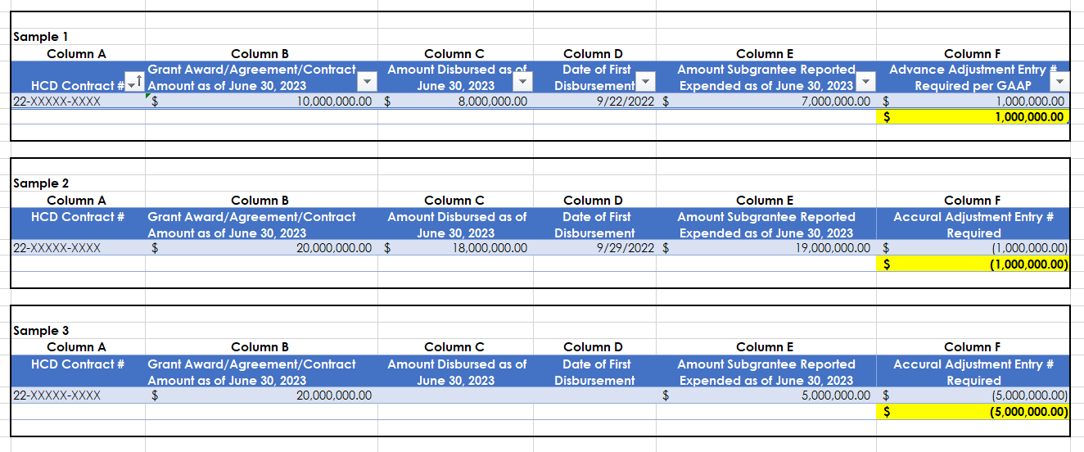
The Accounting Branch Chief provides instructions to the Grant Program Division leads on how to collect data from the Sub-Recipients. These instructions also include parameters on how the programs should report the information back to Accounting.

The following accounting scenarios are provided to the Grant Program Division Leads:
Scenario 1 (Relative to GASB 33 and Codification N50) Scenario Citation Notes Sections ^{1, 2, 6}:
“You paid a grantee prior to fiscal year-end June 30, 20XX more than the costs incurred by that grantee by fiscal year-end June 30, 20XX, this difference would be an advance.”
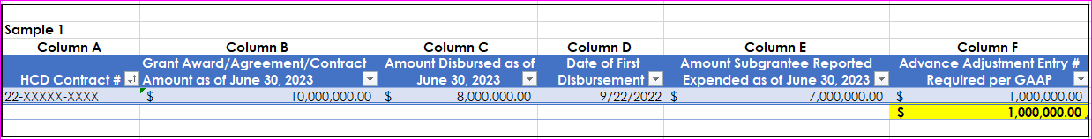
Scenario 2 (Relative to GASB 33 and GASB Codification N50) Scenario Citation Notes Sections ^{3, 5}:
“You paid a grantee prior to fiscal year-end June 30, 20XX end less than the costs incurred by that grantee by fiscal year-end June 30, 20XX, these unreimbursed costs would be accrued as a liability.”

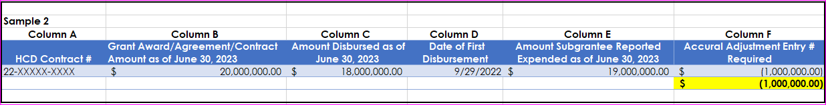
Scenario 3 (Relative to GASB 33 and GASB Codification N50) Scenario Citation Notes Sections ^{3, 5} :
“You paid a grantee after fiscal year-end June 30, 20XX and costs were incurred by that grantee by fiscal year-end June 30, 20XX, there needs to be an accrued liability equal to the full amount of costs incurred.”
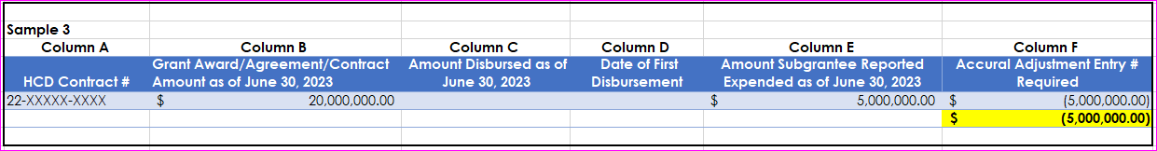

Scenario 4 (Relative to AICPA’s State and Local Govt Guidance Ch 8, and GASB Codification N50) Scenario Citation Notes Sections ^{4,7}:
“No payments have been made to a grantee after fiscal year-end June 30, 20XX. No invoices have been received and there is no current reporting by the grantee. Then, accruals may be booked based on probable costs that program can reasonably estimate have been incurred from grantees by year-end June 30, 20XX based on each unique programs methodology for estimating accruals.”
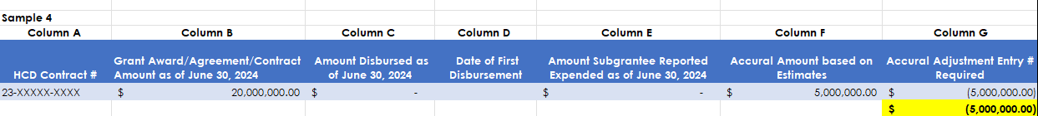
Scenario 5 (Relative to AICPA’s State and Local Govt Guidance Ch 8, and GASB Codification N50) Scenario Citation Notes Sections ^{4,7}:
“Partial payments have been made to a grantee after fiscal year-end June 30, 20XX, or some but not all invoices have been received. Additionally, the grantee’s reporting is either not current or incomplete. Therefore, accruals may be recorded based on estimated costs that are likely to have been incurred by June 30, 20XX, and the reporting by the grantee is not current or incomplete. Then, accruals may be booked based on probable costs that program can reasonably estimate have been incurred from grantees by year-end June 30, 20XX using specific estimation methods for each program.”

This is the A-8 entry that is done at year end for the full amount of the invoice for cost incurred prior to fiscal year-end June 30, 20XX.
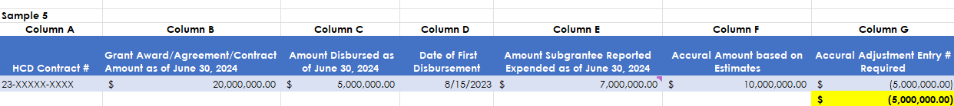
Scenario Citation Notes
¹GAAP Guidance on Advances [GASB 33, Paragraph 15]: “Cash and other assets provided in advance should be reported as advances [assets] by providers and as deferred revenues [liabilities] by recipients until allowable costs have been incurred and any other eligibility requirements have been met.”
²GAAP Guidance on Advances [GASB 33, Paragraph 21]: “Resources transmitted before the eligibility requirements are met should be reported as advances by the provider and as deferred revenues by recipients.”
³GAAP Guidance on reimbursement considerations for Scenario’s 2 and 3 [GASB 33, Paragraph 15]: Governments (including the federal government) frequently engage in award programs commonly referred to as ―reimbursement-type‖ or ―expenditure-driven‖ grant programs. These programs may be either government-mandated or voluntary nonexchange transactions, depending on their characteristics. In either case, the provider stipulates that a recipient cannot qualify for resources without first incurring allowable costs under the provider’s program. That kind of stipulation is not a purpose restriction as defined in this Statement. Rather, it is considered an eligibility requirement (discussed in paragraphs 19 and 20) and affects the timing of recognition. That is, there is no award— the provider has no liability, and the recipient has no asset (receivable)—until the recipient has met the provider’s requirements by incurring costs in accordance with the provider’s program
⁴AICPA's State and Local Govt Guidance on liability recognition for Scenarios 4 and 5 [AICPA Ch 8]: Liabilities should only be recognized when the amount identified is measurable. An amount is measurable only when it can be accurately determined or reasonably estimated.
⁵GAAP Guidance on recognition of liabilities according to Codification of Governmental Accounting and Financial Reporting Standards [N50, section .118]: Providers should recognize liabilities (or a decrease in assets) and expenses from government-mandated or voluntary nonexchange transactions, and recipients should recognize receivables (or a decrease in liabilities) and revenues (net of estimated uncollectible amounts), when all applicable eligibility requirements, including time requirements, are met.
⁶GAAP Guidance on advances according to Codification of Governmental Accounting and Financial Reporting Standards [N50, section .112]: Cash and other assets provided in advance should be reported as advances [assets] by providers and as liabilities by recipients until allowable costs have been incurred and any other eligibility requirements have been met.)
⁷GAAP Guidance on advances according to Codification of Governmental Accounting and Financial Reporting Standards [N50, section .108]: On either basis of accounting, recognition of nonexchange transactions in the financial statements is required unless the transactions are not measurable (reasonably estimable) or are not probable of collection.
The Accounting Branch Chief also provides instructions on how to interpret the above scenarios and a timeline for returning the information.

Below is an example of the deadlines and scenario interpretation guidance provided by the Accounting Branch Chief in the data call:
“As noted above, if this is federal money, then the State is both a grantor and grantee, and therefore, you should re-read the above scenarios from the perspective of the grantee.
For example:
- If [State Department] received a cash advance because the ultimate recipient of the grant (cities, counties) had not incurred any reimbursable costs, you should recognize a liability in the account of Current Portion of Revenues Received in Advance in the total amount of the cash advance.
GAAP Adjustment entries/statements are due to [State Department] on April 30, 20XX and I apologize for the short notice. Can you please confirm whether the programs have/or do not have any expenditure driven grants which meet any of the above requirements and complete the attached template to provide the requested information to Accounting by COB April 29, 20XX.
If you have any questions, please reach out to me for further assistance.
Thank you for your prompt response.
Accounting Branch Chief”

Collect Data Call Responses
As a result of the [Accounting Branch Chief]’s data call, the Grant Program Division leads reach out to the sub-recipients for funding status. The sub-recipients are instructed by the Grant Program Division leads to review their grant program records, and then provide an update on the program expenditures. The sub-recipient’s responses to the request include detailed support for the allowable cost (e.g., expenditures).
Below is a list of example documents received from the sub-recipient that may be accessed via the Key Supporting Documents section:
- Example 1 - Sub-recipient response (email): This document represents correspondence between the Grant Program Division lead and the sub-recipient related to the [Accounting Branch Chief]’s data call. Within the correspondence the Grant Program Division lead is confirming the validity/accuracy of the sub-recipient’s responses, requesting changes to the data, and collecting the finalized expenditure amounts in an attached cash flow report produced by the sub-recipient.

- Example 2 - Detailed Supporting Data: This represents the detailed support provided by the sub-recipient. It includes week-by-week actual expenditure records related to the [CITE PROGRAM NAME] Program. The sub-recipient has documented the actual allowable cost.
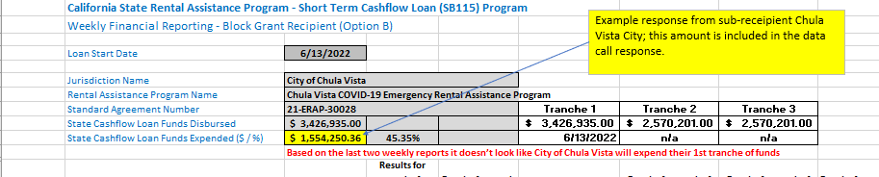
After the Grant Program Division leads have received, validated, and finalized the sub-recipient inputs, the data from all the grant program sub-recipients is aggregated into the “GAAP Adjusted Entries Request from Programs Template” and returned to the Accounting Branch Chief.
Example of a completed “GAAP Adjusted Entries Request from Programs Template”* submitted by a Grant Program Division lead to the Accounting Branch Chief: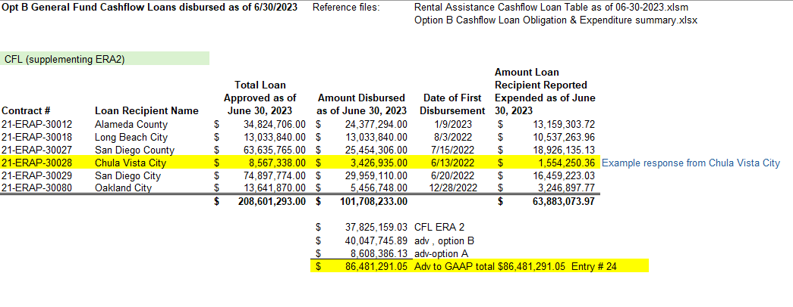*The above referenced document may be accessed via the Key Supporting Documents section as “Example 3 - Program Template Response”.

Validate Responses against FI$Cal Data
The step-by-step detail noted below outlines the process completed to validate program responses relative to contract awards/agreement amounts and amounts disbursed with encumbrances and accounts payable voucher totals. Any variances identified are updated appropriately to reconcile with FI$Cal data.
Step 1: Obtain responses | Review responses from program to validate contract award/agreement amount and amount disbursed matches life to date encumbrances and accounts payable voucher totals respectively, as of June 30th 20XX.
Step 2: Resolve variances | Work to resolve any variances with programs and make appropriate adjustments to reconcile program source data against FI$Cal data.
Step 3: Validate Responses | Validate that the disbursement/expenditure amount doesn’t exceed the total grant amount.

Evaluate Calculation of Estimated Accruals
The steps below outline the review process the department undertakes after receiving accrual estimates from programs. There are multiple levels of review performed at each step. Any issue noted is flagged and sent to the appropriate party to reconcile.
Step 1: Obtain Responses | Department obtains and reviews estimation responses from program.
Step 2: Verify Estimation | Department verifies the accuracy of estimation calculations based on program specific methodology for estimating accruals as described below.
Step 3: Factor in Prior Posting | Department adjusts GAAP Grant Accruals by accruals already posted as part of the governmental fund financial statements.

Consolidate Accrual Entries by Fund
[State Department] Accounting uses a tracker to accumulate all programmatic responses to validate completeness and then sums all Advances and Accruals by fund for purposes of recording the accruals as outlined below.

Record Accruals
Upon receipt of the Grant Program Division lead’s responses to the data call, [State Department] will begin preparing the accounting entries in the “GAAP Entry Workbook for the Annual Comprehensive Financial Report (ACFR).”

Below is an example of the prepared GAAP entries for fund 0890 to reduce the expenditures by the amount of the advance**:

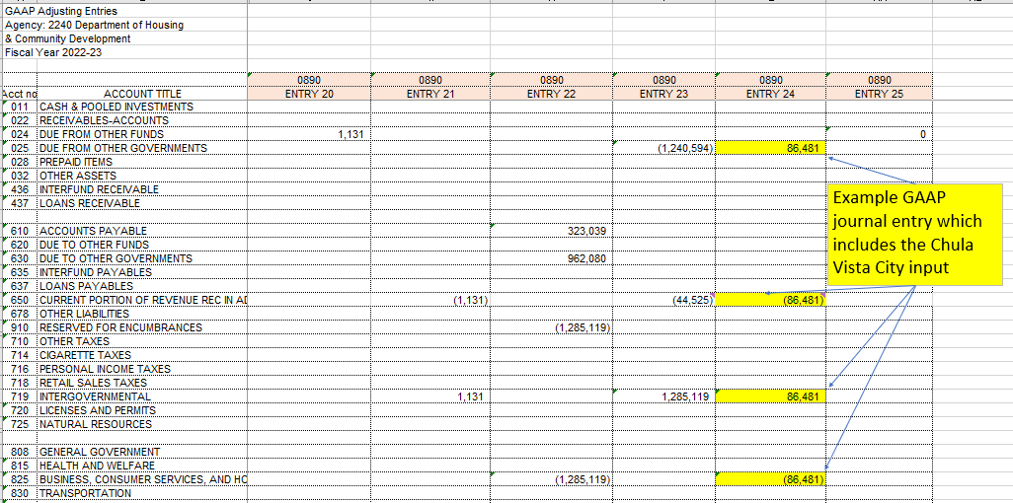**The above referenced document may be accessed via the Key Supporting Documents section as “Example 4 – ACFR GAAP Entry”.

Detailed instructions for completing the “GAAP Entry Workbook for the Annual Comprehensive Financial Report (ACFR)” may be found in the “[State Department] GAAP Procedure and Fiduciary (Desk Guide)” in the Key Supporting Documents section.

Once documents are consolidated, estimates, supporting reports, and program details are reviewed by the department for completeness and accuracy.

Program Procedures

[State Department] Division
The table below outlines the details regarding the [State Department] Grant Program and [Program] Grants
*** Department should prepare this information for each major grant program) ***
Use of Eligibility | Eligible uses are prescribed in the NOFA, reviewed, and approved in the application using a deliverables timetable and enforced through the Standard Agreement. See sample standard agreement language below.  Payments are processed using a standard form and cumulative payment tracker that lists amounts by project and is reviewed utilizing a written business process.
Type of Payment | Reimbursements and Advances; payments are generally on a reimbursement-basis, but advances are allowed upon approval per the standard agreement.
Payment Frequency | Maximum of once per quarter; or upon completion of a deliverable; and a minimum, one invoice for reimbursement annually.
After an advance, a final invoice is submitted, documenting proposed uses, deliverables, and amounts through a written business process, and is accompanied by a close out report.
Below is the process by Program to identify grantee expense and invoice data to evaluate accruals:
# | Description
1 | Reimbursements are tracked on a received basis and reported and reviewed weekly in a reimbursement team meeting. Among other tracked items, amount received, amount under review, amount under management review, amount dispersed and amount unclaimed are summarized.
2 | Reimbursement team receives and reviews annual reports in conjunction with reimbursements on a received basis.
3 | Accrual information request is received by Procedures Guidance and Information (PGI) staff from [State Department] Accounting.
4 | PGI staff uses cumulative funds request tracker to calculate estimated expenditure accruals based on payment request amounts and dates.
5 | PGI staff inputs the accrual data for each applicable scenario and returns information to [State Department] Accounting.
Below are the source documents that validate the completeness of eligible grantees:
Source Document | Description
Annual Report | [Program] Grants did not require an annual report. Other [Program] required an Annual Report by statute that reported on the status of proposed uses and expenditures to date.
NOFA/Other | NOFA/Application/Standard Agreement/Payment Form/Payment Tracker/Business Process.
Sample Standard Agreement Language:
The Grantee shall submit invoices for reimbursement to the Department. All invoices shall be subject to the Department’s approval and submitted in accordance with the following schedule:
- At maximum, once per quarter; or
- Upon completion of a deliverable; and
- At minimum, one invoice for reimbursement annually
The Department will use the 2020 calendar year beginning from the date of the release of the NOFA on January 27, 2020, as the basis for scheduling reimbursements, with first requests for reimbursement accepted upon full execution of the Agreement by the Grantee and the Department.
The Request for Reimbursement must be for a minimum of fifteen percent (15%) of the maximum grant amount awarded. The Department may consider exceptions to the minimum amount requested on a case-by-case basis. All invoices shall reference the contract number and shall be signed and submitted to the Department’s Program Manager at the address provided above in Section 6, Subsection D of this part.

Key Supporting Documents
Key Supporting Documents referenced during the development of this procedure or specifically cited in this narrative include, but are not limited to, the following:
Report Description | File
Example 1 - Sub-recipient response (email)
Example 2 - Detailed Supporting Data
Example 3 - Program Template Response
Example 4 - ACFR GAAP Entry
[State Department] GAAP Procedure and Fiduciary (Desk Guide)

Acronyms
The list of key acronyms found in this document may be found in the table below.
Acronym | Description
ACFR | Annual Comprehensive Financial Report
FI$Cal | Financial Information System for California
FMB | Financial Management Branch
GAAP | Generally Accepted Accounting Principals
GAM | Grant Administration Manual
GASB | Governmental Accounting Standards Board
SAM | State Administration Manual
SCO | State Controller’s Office
SGM | State Grants Management
SOP | Standard Operating Procedure
SPMs | System Performance Measures

